**Asthma**

**Introduction**

Airway diseases have gradually increased in the recent decade despite the therapeutic advance. More worrying is the fact that their prevalence is underestimated based on recent epidemiological surveys, which further compound the complexity of managing these diseases (Athanazio, 2012). The purpose of this paper is to identify the pathophysiological mechanisms of chronic and acute asthma exacerbation, explain how genetics impact pathophysiology of these disorders, and provide a description of diagnosis and treatment based on this investigated (genetics) factor.

Pathophysiology of asthma is a complex process which encompasses airway inflammation, intermittent airflow obstruction and bronchial hyper-responsiveness.

**Inflammation of the Airway**

Asthmatic inflammation of the airway may be considered to be either acute or chronic. Airway edema and mucus secretion may also lead to airway blockage and bronchial sensitivity. Some exogenous and endogenous stimuli may induce radical bronchial response; what is sometimes referred to as bronchial hyper-reactivity. Stimulation may be considered to be either direct; through contact with airway smooth muscles, or indirect; through stimulation of pharmacologically agents such as mast cells. In summation, Morris (2017) found hyper-responsiveness in patients to be directly proportional to the clinical severity of asthma.

**Obstruction of the Airway**

When the airway has been obstructed, a resistance to flow of air is impeded leading to a reduced rate of gaseous exchange. Obstruction of the airway may be due to one, two or all of the following; bronchoconstriction, airway remodeling, mucus blockage and air- passage edema. The initial asthmatic reaction is characterized with acute bronchoconstriction. Airway edema may follow from about 6 hours secondary to allergenic exposure which is a later response. Exudate of serum proteins and cell debris forms a mucus plug which also contributes to air-passage blockage; this normally takes weeks to resolve (Morris, 2017).

**Bronchial Hyper-responsiveness**

Hyperinflation does work in compensation of airflow obstruction, but this compensation is limited by the approach of the tidal volumes and the volume of the pulmonary dead space resulting into alveolar hypoventilation (Morris, 2017).

Exacerbation in asthma may manifest as either acute or chronic. The conditional deterioration in both cases tends to be identical, however, in acute asthma the radical changes in exchange rates is highly noticeable. Exposure to inducing agents such as virus and environmental pollutants, worsen the condition of the patient in both types of asthma. Exposure to allergen is however specific to acute asthma. On the other hand, chronic asthma exacerbation has been found to be more of a product of bacterial infection. Patient avoidance of possible inducing agents and environment has proven an effective delay means of on-setting these conditions exacerbation (Pauwels, 2004)

The genetic makeup of an individual predisposes one to have asthma. It is believed that three-fifths of asthma cases are hereditary. If any of the parents are asthmatic, then their child is three to six times more likely to develop asthma in comparison to a child with non-asthmatic parents (Benaroch, 2016). Through positional cloning asthma genes or gene, complexes have been identified as ADAM, PHF11, DPP10, GRPA and SPINK5. The roles of these genes remain rather vague. However the expression of DPP10, GRPA and SPINK5 in terminally differentiating epithelium is that they counter threats from the external environment. Most of the genes identified by candidate genes studies may also exert their effect within the cells that make up the mucosa (Blakey, Sayers, Ring, Stranchan, & Hall, 2009). Understanding the asthma susceptibility genes helps identify potential target for the right asthmatic therapy prescription.

Mind Map for Acute Asthma (El, Acute Asthma, 2013)

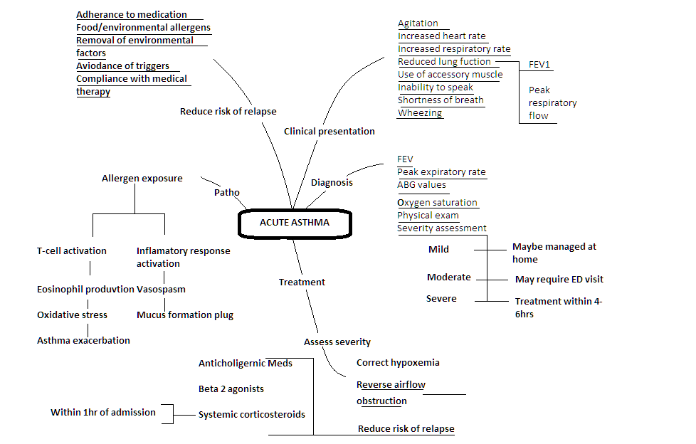

Mind Map of Chronic Asthma (El, Chronic Asthma, 2013)

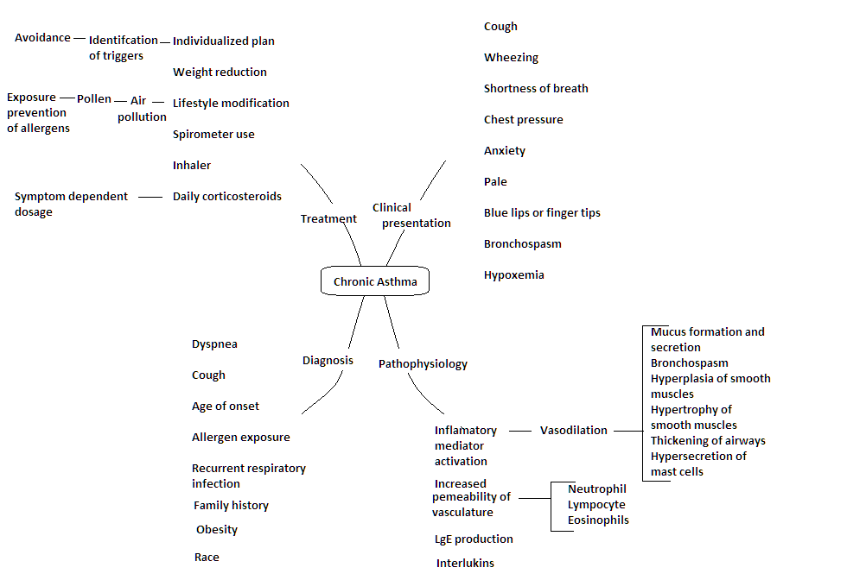

**Conclusion**

Asthma exacerbations give a more pronounced picture of the lower airway response to an environmental stimulus. Airway inflammation is a development indicator of asthma exacerbation. Avoidance of trigger agent is notably a key method of delaying/preventing asthmatic attacks. However, owing to the numerous trigger agents and patient factors, when the attacks occur , thorough diagnosis should be conducted to ensure the patient is placed on the most effective treatment regime.

# References

Athanazio, R. (2012). Airway Disease: Similarities and Differences between Asthma,COPD and Bronchiectasis. *Clinics(Sao Paulo)*, 1335-1343.

Benaroch, R. (2016, February 16). *Asthma Risk Factors.* Retrieved October 6, 2017, from WebMD: https://www.webmd.com/asthma/guide/asthma-risk-factors#1-3

Blakey, J. D., Sayers, I., Ring, S. M., Stranchan, D. P., & Hall, I. P. (2009). Positionally Cloned Asthma Susceptibility gene Polymorphisms and Disease Risk in the British 1958. *Thorax* , 381-387.

El, S. (2013). *Acute Asthma.* Retrieved September 28, 2017, from Mindmeister: https://www.mindmeister.com/306256404/acute-asthma

El, S. (2013). *Chronic Asthma.* Retrieved September 28, 2017, from Mindmeister: https://www.mindmeister.com/306011504/chronic-asthma

Gibson, P. G., & Wark, P. A. (2006). Thorax. *PMC*, 909-915.

Morris, J. M. (2017, April 25). *Asthma.* Retrieved September 28, 2017, from Medscape: http://emedicine.medscape.com/article/296301-overview#a2

Pauwels, R. (2004). *Similarities and Differences in Asthma and Chronic Obstructive Pulmonary Disease Exacerbations.* Retrieved October 6, 2017, from NCBI Resources: https://www.ncbi.nlm.nih.gov/pubmed/16113416