Chronic and Acute Asthma Exacerbation
Introduction
Breathing is an essential part of human life, with every individual making an average of two thousand five hundred strokes of breath in a day. However, asthma attacks compromise the ability of a person to breath normally as they experience an immense shortage of air penetrating to their lungs, making it a difficult and painful experience. Such incidences may result to unexpected death as a complete cut off air supply can make any person lifeless within the shortest time possible. Asthma exacerbation, which can be experienced in chronic and acute episodes, is characterized by continued wheezing, deteriorating state of breath, intense coughing, and a squeeze of the chest muscles. Even though some asthmatic patients experience individual symptoms, some cases are characterized by the occurrence of all the signs at the same time (Chen et al., 2013). In such an exacerbation scenario, the lifespan of the patient is decreased even further. This paper highlights the pathophysiological mechanisms through which chronic and acute asthma are manifested. Besides, it provides a vivid discussion on the changes that take place in the arterial gas patterns during an exacerbation. Also, the paper explains the diagnosis frameworks for a patient suffering from acute or chronic asthma. Asthma exacerbation complications vary depending on different factors, and immense caution should be taken to avoid the occurrence of death.
Discussion
In the nursing sector, the understanding of the pathophysiological aspects of asthma has changed rapidly in the recent years due to continuous research studies that reveal the specific elements of chronic and acute asthma infections (Green & Thorogood, 2013). Besides, there has been a change in the administration of therapy to patients within the shortest time possible based on molecular and cell science. In essence, the pathophysiological process of both acute and chronic asthma revolves around understanding the dynamics that take place in the human body before a patient undergoes exacerbation. In this respect, it has been ascertained that asthma is caused by inflammation of the breathing airspace (Oinas-Kukkonen, 2013). The chronic phase is the first stage to appear and is characterized by increased production of mucus, an action that triggers an immense reaction from the internal system of the airways. In return, the breathing airway is compressed, and the patient finds it hard to properly access air. The acute phase of asthma occurs when the airspace is completely blocked, and the person is unable to breath or can only breath after long inter phases.
The inflammatory process is caused by a combination of many cells which swell more than their normal sizes during the beginning of the process or as a reactive mechanism. For example, cytokines act as chronic inflammatory mediators alongside other secretions such as endothelin and nitric oxide (Ozier et al., 2011). The epithelial cells found on the walls of the breathing airways are responsible for secreting cytokines and the other mediators. One of the impacts of the inflammatory process is the constriction of the bronchus, which is responsible for the wheezing and other mechanical problems witnessed by chronic and acute asthma patients. Other aspects that take place during exacerbations include neural process activation and exudation of the neural plasma.
Various factors are responsible for the occurrence of chronic and acute asthma in patients across the world. Exacerbation has been linked to genetic, environmental, nutritional, emotional, and infectious factors (Green & Thorogood, 2013). Due to the physical struggle encountered during exacerbations, patients are likely to develop emotional stress, an aspect that worsens the condition even further as depressive phase of the illness is initiated in the process. Besides, physical factors such as gender, allergies, ethnic backgrounds, age, and lifestyle behavior of individuals have been linked to various cases of chronic and acute asthma. In this paper, I will discuss how human behavior contributes to chronic and acute asthma infections.
Individual behavior such as smoking, poor food diets, drug and substance abuse, exercise, keeping of untreated pets, and some hobbies can be directly linked with asthma infections. A change in the diet of a person, including an increased frequency of omega-6 fatty acids, predisposes an individual to asthma attacks. Besides, increased incidences of asthma-related cases can be attributed to reduced consumption levels of magnesium minerals. In essence, a shift from the tradition eating lifestyle that provided a balanced diet to the modern fast foods has played a significant role in increased cases of asthmatic infections. There is also increased use of fossil fuels especially in the cities and other urban places, a factor which accounts for the higher number of asthmatic cases recorded in urban zones (Oinas-Kukkonen, 2013). Asthmatic infections can also be obtained from vaccinations that are administered to children in their early age, especially below six years. Such vaccines contain substances that are likely to cause respiratory tract infections, increasing the risk of having asthma.
The intensive exercise routine is also a human behavior that predisposes someone to asthmatic attack. During exercise, the airway epithelium is exposed to the cold, and other environmental factors as the person breathe heavily. In most cases, the cold, dry air triggers reactions from the breathing tract including the secretion of inflammatory hormones in the cells (Shaw et al., 2010). In the end, a person who has intensive routine exercises especially in cold and polluted areas is likely to be affected by asthma. Various compounds found in cigarettes and drugs are attributed to asthma cases, especially in sensitive individuals. In essence, some of the substances produced by drugs such as cocaine and marijuana may prompt the respiratory airway to respond in a hyper mode, trying to eradicate the intrusions. In the process, an individual develops inflammatory and other related complications that may develop to chronic and acute asthma (Shaw et al., 2010). It is clear that human behavior, including hobbies such as mountain climbing or racing in dusty areas, exposes an individual to external substances which are inhaled and disposed on the respiratory tract. In this respect, asthmatic complications are mostly developed when the body induces natural mechanisms of fighting the foreign particles. This explains why mucus production is one of the elements of the process.
Diagnosis of chronic and acute asthma can be done by pulmonary function tests including spirometry, which measures the amount of air that a patient can inhale and exhale, mostly recommended for acute cases (Fig. 1). Besides, peak expiratory meters are used to measure chronic asthmatic cases such as in homes (Ozier et al., 2011). Other cases include bronchial tests such as direct and indirect challenge tests, bronchodilator reversibility tests, and before and after tests. The bronchial tests are used to observe the reaction of the respiratory system to the external particle. Besides, allergy testing can also be done to ascertain if the condition is related to allergic reactions. Besides, laboratory data can be used to relate the case to other causes such as genetic alignment (Fig. 2).
Mind Maps
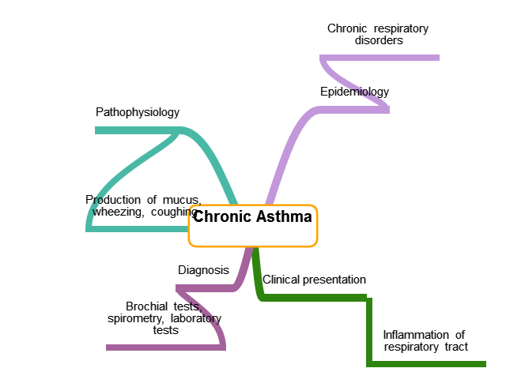
Figure 1: Chronic Asthma Mind Map
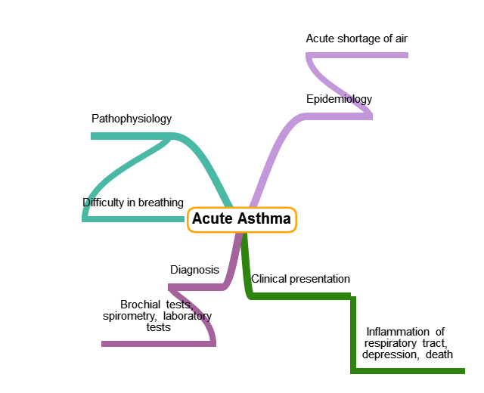
Figure 2: Acute Asthma Mind Map

Conclusion
The discussion provides a vivid understanding of the chronic and acute asthmatic exacerbations. Predisposing factors such as human behavior should be closely monitored to avoid an increase in asthmatic cases, especially in urban areas. Early diagnosis is also vital if any of the symptoms are observed.
References
Chen, W., Boutaoui, N., Brehm, J. M., Han, Y. Y., Schmitz, C., Cressley, A., ... & Weeks, D. E. (2013). ADCYAP1R1 and asthma in Puerto Rican children. American journal of respiratory and critical care medicine, 187(6), 584-588.
Green, J., & Thorogood, N. (2013). Qualitative methods for health research. London: Sage.
Oinas-Kukkonen, H. (2013). A foundation for the study of behavior change support systems. Personal and ubiquitous computing, 17(6), 1223-1235.
Ozier, A., Bara, I., Girodet, P. O., Marthan, R., & Berger, P. (2011). [Pathophysiology of asthma]. La Revue du praticien, 61(3), 339-345.
Shaw, S. J., Huebner, C., Armin, J., Orzech, K., & Vivian, J. (2010). The role of culture in health literacy and chronic disease screening and management. Journal of Immigrant and Minority Health, 11(6), 460-467.

