DIABETES TYPE 2
Diabetes Mellitus
Diabetes mellitus is a metabolic disorder characterised by persistent high glucose levels in blood. The hyperglycaemia persists due to either failure of insulin production or tissues resistance to insulin (Yorek et al., 2015; Barron, 2010). Insulin is produced by the pancreas. Diabetes mellitus can subdivided into three types; type 1 diabetes mellitus, type 2 diabetes mellitus, and gestational diabetes mellitus (Habtewold, Tsega & Wale, 2016; Yorek et al., 2015; Barron, 2010). This assignment will primarily focus on a patient with type 2 diabetes mellitus.
Type 2 diabetes results from the body failing to effectively utilize the insulin produced by the pancreas. The malfunction is referred is known as insulin resistance. The result is hyperglycaemia that is associated with the presenting symptoms of diabetes (Stoian et al., 2015; Lazo et al., 2014)
Normal Physiology of the Pancreas
Insulin regulates glucose uptake into cells for metabolism and storage. The pancreatic islets produce the hormone insulin (DeWit, Stromberg & Dallred, 2017). The pancreas is both endocrine and exocrine gland. It produces vital enzymes for digestion as well as the hormone insulin (Barron, 2010). Insulin is produced and released directly in the blood to influence glucose uptake in most cells of the body. The release of insulin is triggered by high blood glucose levels by the glucose sensitive beta cells of the pancreas. When glucose levels decrease, the secretion of insulin is inhibited (TAO, 2014). To maintain glucose homeostasis, the pancreas also secretes glucagon hormone which allows the release of glucose from storage into the blood stream during hypoglycemia (Barron, 2010; DeWit, Stromberg & Dallred, 2017).
The islets of Langerhans is comprised of four different types of cells namely alpha, beta, delta, and gamma. Among the four types, two are primary in regards to glucose homeostasis: alpha and beta cells (TAO, 2014; HINKLE, & CHEEVER, 2014).
The alpha cells comprise about 20% of all the islet’s cells. They secrete the hormone named glucagon which increases blood sugar to maintain normal levels so that glucose can get broken down once sugar levels drop (Waters, 2014; TAO, 2014). The making and release of glucagon in the pancreas is controlled by chemoreceptors through the body that are sensitive to the levels of sugar in the blood. When the blood sugar levels drop too low, the chemoreceptors signal the alpha cells in the pancreas to release the hormone glucagon which is transported via blood to the liver. Glucagon acts on hepatocytes hepatocytes to break down glycogen into the glucose through a process referred to as glycogenesis (Barron, 2010; DeWit, Stromberg & Dallred, 2017).
. Beta cells on the other hand comprise almost 80% of the islet cells. The beta cells are responsible for secretion of insulin. The hormone insulin decreases the blood sugar in response to signals from chemoreceptors. When the levels of blood sugar are high, the beta cells are stimulated to release insulin.
Delta cells, also a bit significant in glucose homeostasis comprise of less than 1% of pancreatic islets. They secrete somatostatin, a growth-hormone-inhibiting hormone secreted by the hypothalamus. The hormone inhibits insulin release and slows absorption of nutrients from the gastro-intestinal tract. Lastly, Gamma cells are responsible for the secretion of a pancreatic polypeptide that inhibits the release of somatostatin. Delta and Gamma cells are simultaneously self-regulating hormones that are antagonistic to each other (Barron, 2010; DeWit, Stromberg & Dallred, 2017; TAO, 2014).

Pathophysiology of Diabetes Type 2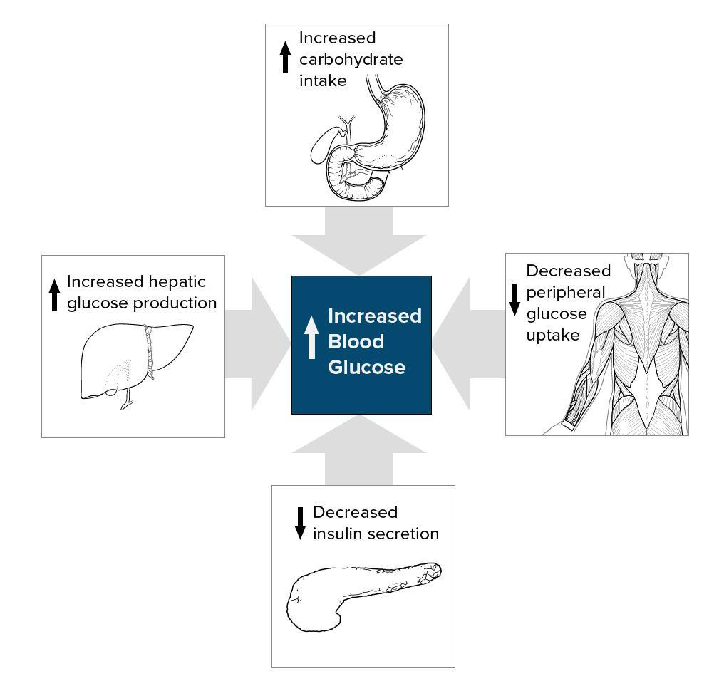
(Medscape, n.d.)
Low amount of insulin coupled with insulin resistance of cells lead to high blood glucose levels. The result is poor protein synthesis, and other metabolic derangements, such as acidosis (TAO, 2014). Persistent high glucose levels outrun the kidneys ability for reabsorption and glucose is excreted in urine (DeWit, Stromberg & Dallred, 2017). Osmotic pressure of urine increases impairing the ability of the kidneys to reabsorb water. More water is lost leading to excessive polyuria and fluid from the cells is lost to replace lost volume. The result is polydipsia (TAO, 2014; HINKLE, & CHEEVER, 2014).
Case in Point
Patient background: Isaac is a 56-year-old man who was admitted to a medical ward due to a fall. Isaac was diagnosed with uncontrolled type 2 diabetes 32 years ago, after complaining of excessive thirst and unusual frequent urination. He is currently presented with unintentional weight loss and peripheral neuropathy; his past medical history consists of type 2 diabetes and hypertension. Isaac does not take his insulin regularly, which may be the reason why he is losing weight. Isaac’s experience of peripheral neuropathy may have caused his fall as he had no sensation to his feet
Isaac is reported to have missed several doses of insulin. Lack of adequate amounts of insulin leads to persistently high blood glucose levels. Glucose does not move to the cells for breakdown to release energy for the body cells to function (HINKLE & CHEEVER, 2014). As a result of low insulin, the body starts to breakdown fat and muscles for energy. The process leads to a rapid reduction of reduction in the overall body weight. The continuous breakdown of stored fats and muscles explains the unintentional weight loss (Syngle et al., 2014).
Persistent high glucose levels interferes with the nerves ability to conduct impulses. In addition, hyperglycaemia damages microcirculation supplying blood to nerve fibres (Won et al., 2012; HINKLE & CHEEVER, 2014). The delicate nerve fibres get damaged resulting to peripheral neuropathy. Decreased sensory perception follows, and falls and other traumatic accidents easily arise in uncontrolled diabetic patients (Li et al., 2014; Won et al., 2012). Isaac’s fall can be attributed to poor nervous function and muscle wasting from fat and muscle breakdown.
Isaac’s failure to use insulin consistently exposes him to consistently high blood glucose levels. His microcirculation is therefore compromised as a result or vessel hardening (HINKLE & CHEEVER, 2014). When microcirculation to the heart and kidneys is compromised, kidney function and the pumping mechanism of the heart are affected. The result is usually cardiovascular abnormalities including high blood pressure (TAO, 2014). Hardened vessels due to persistent high blood glucose and poor oxygen supply to microcirculation, including those supplying the heart raise the blood pressure (HINKLE & CHEEVER, 2014). Isaac’s history of hypertension can be attributed to the above anomalies.
References
Barron, J., 2010. The Endocrine System: The Pancreas & Diabetes. [Online]
Available at: https://jonbarron.org/diabetes-blood-sugar-levels/endocrine-system-pancreas-diabetes. [Accessed 21 October 2016].
Chin, Y, Huang, T, & Hsu, BR 2013, 'Impact of action cues, self-efficacy and perceived barriers on daily foot exam practice in type 2 diabetes mellitus patients with peripheral neuropathy', Journal of Clinical Nursing, vol. 22, no. 1/2, pp. 61-68. Available from: 10.1111/j.1365-2702.2012.04291.x. [8 February 2017].
DeWit, S. C., Stromberg, H., & Dallred, C. (2017). Medical-surgical nursing: Concepts & practice.
Habtewold, TD, Tsega, WD, & Wale, BY 2016, 'Diabetes Mellitus in Outpatients in Debre Berhan Referral Hospital, Ethiopia', Disease Markers, pp. 1-6. Available from: 10.1155/2016/3571368. [8 February 2017].
HINKLE, J. L., & CHEEVER, K. H. (2014). Brunner & Suddarth's textbook of medical-surgical nursing.
Lazo, MA, Bernabé-Ortiz, A, Pinto, ME, Ticse, R, Malaga, G, Sacksteder, K, Miranda, JJ, & Gilman, RH 2014, 'Diabetic Peripheral Neuropathy in Ambulatory Patients with Type 2 Diabetes in a General Hospital in a Middle Income Country: A Cross-Sectional Study', PLoS ONE, vol. 9, no. 5, pp. 1-5. Available from: 10.1371/journal.pone.0095403. [7 February 2017].
Li, G, Sun, C, Wang, Y, Liu, Y, Gang, X, Gao, Y, Li, F, Xiao, X, & Wang, G 2014, 'A Clinical and Neuropathological Study of Chinese Patients with Diabetic Peripheral Neuropathy', PLoS ONE, vol. 9, no. 3, pp. 1-5. Available from: 10.1371/journal.pone.0091772. [8 February 2017].
Park, H, Park, C, Quinn, L, & Fritschi, C 2015, 'Glucose control and fatigue in type 2 diabetes: the mediating roles of diabetes symptoms and distress', Journal of Advanced Nursing, vol. 71, no. 7, pp. 1650-1660. Available from: 10.1111/jan.12632. [8 February 2017].
Stoian, A, Bănescu, C, Bălaşa, RI, Moţăţăianu, A, Stoian, M, Moldovan, VG, Voidăzan, S, & Dobreanu, M 2015, 'Influence of GSTM1, GSTT1, and GSTP1 Polymorphisms on Type 2 Diabetes Mellitus and Diabetic Sensorimotor Peripheral Neuropathy Risk', Disease Markers, vol. 2015, pp. 1-10. Available from: 10.1155/2015/638693. [6 February 2017].
Syngle, A, Verma, I, Krishan, P, Garg, N, & Syngle, V 2014, 'Minocycline improves peripheral and autonomic neuropathy in type 2 diabetes: MIND study', Neurological Sciences, vol. 35, no. 7, pp. 1067-1073. Available from: 10.1007/s10072-014-1647-2. [7 February 2017].
TAO, Y.-X. (2014). Glucose homeostatis and the pathogenesis of diabetes mellitus.
Won, JC, Kwon, HS, Kim, CH, Lee, JH, Park, TS, Ko, KS, & Cha, BY 2012, 'Prevalence and clinical characteristics of diabetic peripheral neuropathy in hospital patients with Type 2 diabetes in Korea', Diabetic Medicine: A Journal Of The British Diabetic Association, vol. 29, no. 9, pp. e290-e296. Available from: 10.1111/j.1464-5491.2012.03697.x. [8 February 2017].
Yorek, MS, Obrosov, A, Shevalye, H, Holmes, A, Harper, MM, Kardon, RH, & Yorek, MA 2015, 'Effect of diet-induced obesity or type 1 or type 2 diabetes on corneal nerves and peripheral neuropathy in C57Bl/ 6J mice', Journal of the Peripheral Nervous System, vol. 20, no. 1, pp. 24-31. Available from: 10.1111/jns.12111. [6 February 2017].

