ASSIGNMENT: ASTHMA AND STEPWISE MANAGEMENT

Introduction
Asthma is an inflammatory disease, characterised by the narrowing and swelling of the airways, as well as production of extra mucus, leading to difficulty in breathing, coughing, wheezing, and shortness of breath (Arcangelo et al., 2006). Asthma affects people of all ages and comes in either minor or serious forms. Depending on the severity of asthma attacks, one may need different types of management. The differences in management has led to the designing of the stepwise approach, which is reviewed in this paper together with long term and quick reliefs that may be offered to patients.

Describe long-term control and quick relief treatment options for asthma patients
Because asthma manifests in different forms and degrees, there is no one-side-fit-all treatment option. Generally, treatment may be either short term relief or long-term control. The long-term control treatments are taken on daily basis and aim to suppress the occurrence of symptoms as much as possible. Flovent, Advair, long-acting beta agonists (LABA), and other oral medications are examples of long-term control treatments. The main impact of the long-term treatment is that it has the potential of eradicating the symptoms for as long a time as possible (Chung, 2015). The short-term or quick relief treatment seek to offer immediate comfort for current and sudden symptoms or attacks (Arcangelo et al., 2006). These quick reliefs may either lead to the cessation of symptoms for particular episodes or give patients temporary reliefs till long-term controls or medications are available. It is for this reason that the quick relief treatments, some of which are medications are referred to as rescue medications (Chung, 2015). It is therefore possible that while using long-term control medications, there may be sudden episodes, which will call for the need to administer or use quick relief treatments such as inhalers.

Explanation of the stepwise approach
As the name suggests, the stepwise approach tackles the management and treatment of asthma in a systematic manner, following one phase at a time (Dunn, Neff & Maurer, 2017). The stepwise approach as depicted in the image below requires that patients will be diagnosed and placed at one step depending on the symptoms they exhibit. At each step, recommended medications and their alternative therapies are suggested. Depending on the outcome of treatment, the health professionals may decide to increase doses and treatments by moving patients further along the ladder.
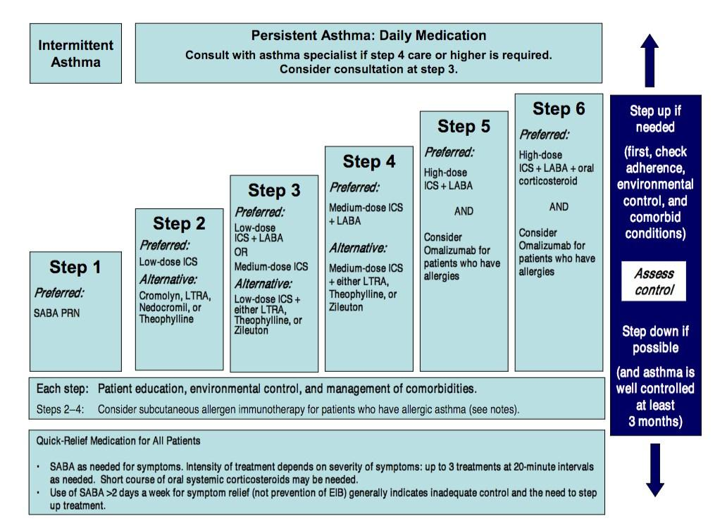
Source: Garhy (2017)
One significant aspect of the stepwise approach is that it does not necessarily require treatment to move step up but could also move step down, if assessment of patient’s condition shows that the disease has been well controlled for a particular step after it has been administered for 3 months. It is important to stress however that the stepwise approach only comes to supplement, rather than replace clinical decisions that health professionals find useful in meeting individual needs of patients (Dunn, Neff & Maurer, 2017).

Benefits of stepwise approach in gaining and maintaining control of the disease
There are several benefits and advantages for using the stepwise approach. For the health care provider, the systemic nature of the approach in itself is a guiding principle to gain and maintain control of the disease. This is because the approach is in a pre-format form, only requiring the service provider to undertake an accurate diagnosis to know the step to start treatment. What is more, the approach helps health care providers to gain control of the disease because of its universality. That is, it is very simple and common to apply the approach to all patients who exhibit the same symptoms, regardless of where they may come from (Inoue et al., 2017). Consequently, health professionals do not have to know so much about the patient in order to offer treatment but that knowing about the disease as manifested by its symptoms alone is enough. Again, Inoue et al. (2017) opined that using the stepwise approach helps in minimising errors and mistakes that may arise from the haphazard and unplanned delivery of treatment. For example if there was no such system of management as the stepwise approach, health care providers would always have to come up with something new that works for each individual. Doing this could increase the chances of medication errors arising from trial and error regime of care.

Conclusion
From the discussions above, it would be appreciated that even though asthma could be a life threatening disease, there are treatment and management options, which when followed carefully can offer relief to patients. The relief that come with such management approaches such as stepwise could range from the short term to long term. Practice nurses are however the facilitators of such treatments, meaning they always have to equip themselves with advance knowledge that makes it possible for them to offer assistance to patients when they will need them most.
References
Arcangelo, V. P., & Peterson, A. M. (Eds.). (2006). Pharmacotherapeutics for advanced practice: a practical approach (Vol. 536). Lippincott Williams & Wilkins.
Chung, K. F. (2015). Targeting the interleukin pathway in the treatment of asthma. The Lancet, 386(9998), 1086-1096.
Dunn, N. A., Neff, L. A., & Maurer, D. M. (2017). A stepwise approach to pediatric asthma. Journal of Family Practice, 66(5), 280-286.
Garhy, N. (2017). Asthma management: Stepwise approach explained. https://forum.facmedicine.com/threads/asthma-management-stepwise-approach-explained-2017.29896/
Inoue, H., Nagase, T., Morita, S., Yoshida, A., Jinnai, T., & Ichinose, M. (2017). Prevalence and characteristics of asthma–COPD overlap syndrome identified by a stepwise approach. International journal of chronic obstructive pulmonary disease, 12, 1803.

