**Path Analysis**

**Path Analysis #1**

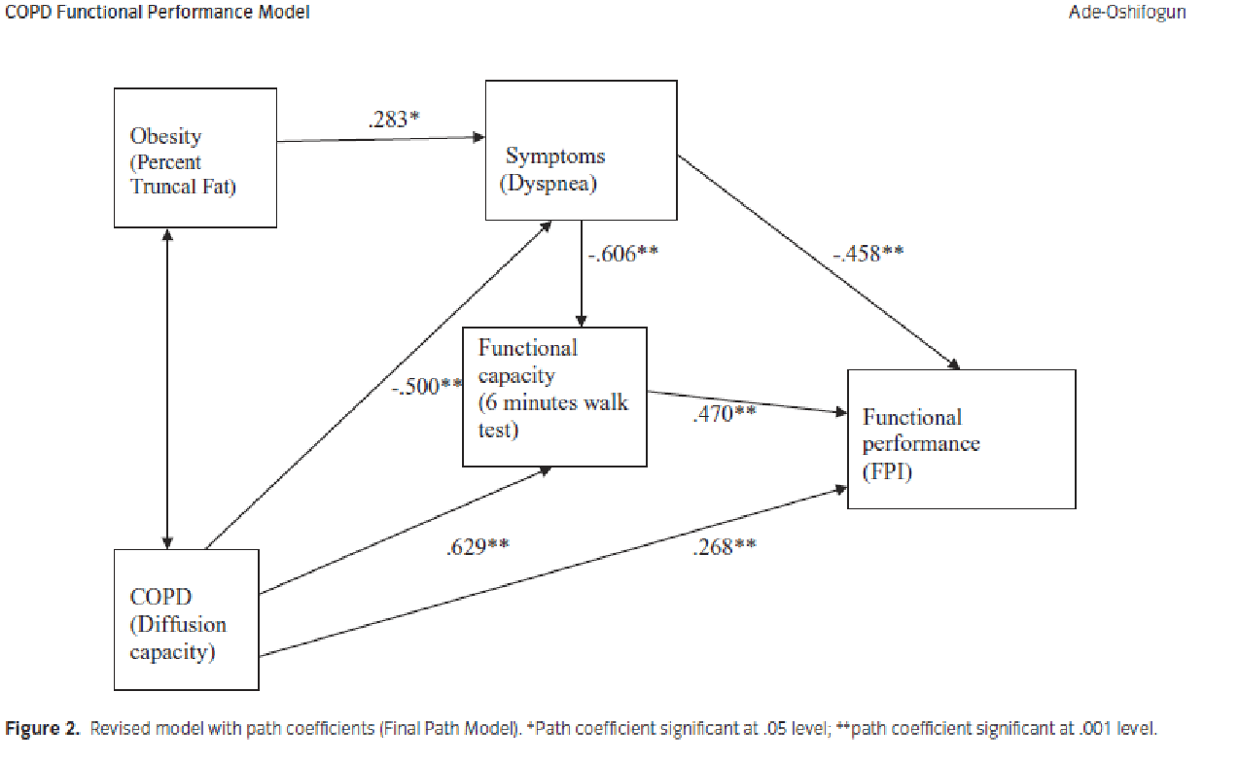

1. *Identify the significant relationships on the diagram.  Provide the names of the concepts that are related and the path coefficient number for each.*

The path analysis shows two predictor variables namely obesity (percent truncal fat) and chronic obstructive pulmonary disease. Diffusion capacity as well as one outcome variable called functional performance (FPI) obesity (percent truncal fat) has some direct link with the symptoms (Dyspnea) with a path coefficient of .283*. This reveals the direct relationship as more percent truncal fat causes more symptoms (Dyspnea) to occur. Conversely, the signs (Dyspnea) have a direct effect on the functional capacity with a path constant of .458** which can be interpreted as an inverse association. This implies that reduction in the symptoms will result in an increase in functional performance. Moreover, there is a correlation between symptoms and functional capacity (6 minutes’ walk) having a path coefficient of -.606** indicating that there is an inverse relationship (Clayton & Pett, 2011). In summary obesity is associated with functional performance indirectly and the facilitating effect are symptoms (Dyspnea) and functional capacity (6 minutes’ walk). For COPD, direct association exists with function performance with a path coefficient of .268** (Clayton & Pett, 2011). This indicates a direct relationship between the variables. COPD further has some association with the symptoms (Dyspnea) directly with a path coefficient of -500** (Clayton & Pett, 2011).

1. *Which two concepts have the strongest direct influence on functional performance?  Report the path coefficient number for each.*

* Symptoms (Dyspnea): -.458**
* Functional capacity (6 minutes’ walk): 470**

1. *What the relationship between dyspnea and functional capacity? Report the path coefficient.*

Dyspnea is inversely proportional to functional performance suggesting that an increase in dyspnea will lead to a reduction in functional performance with a path coefficient of -.458**.

**Path Analysis #2**

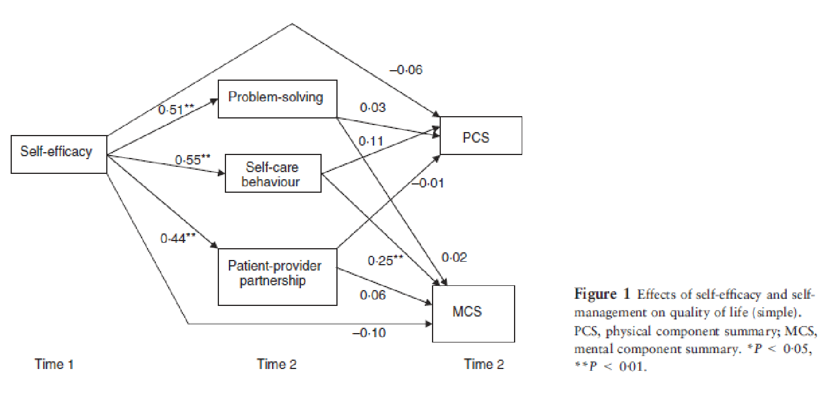

1. *Identify the significant relationships between self-efficacy and other concepts. Provide the name of the concepts that are related and the path coefficient number for each.*

Self-efficacy has direct association with PSC with a path coefficient of 0.06, which depicts a direct proportionality. Again, self-efficacy is associated directly with problem solving having a path determinant of 0.51** (Pett & Clayton, 2010). Self-care conduct has a path determinant of 0.55** and an ailing provider having a path determinant of 0.44** both of which have direct proportionality. Self-efficacy also has an inverse connection with MCS that has path determinant of -0.10 (Pett & Clayton, 2010).

1. *Identify the concept and path coefficient number for the concept with the strongest relationship with self-efficacy*.

Self-care behavior with a path coefficient of 0.55**and the relationship is inverse.

1. *Which concepts have a significant relationship with Mental Component Summary (MCS)? Report the path coefficients.*

Concepts with important relationship on MCS are;

* Problem solving (path determinant of 0.11)
* Self-care behavior (0.25**)
* Patient provider partnership (path coefficient 0.06)
* Self-efficacy (path coefficient of -1.10)

**Path Analysis #3**

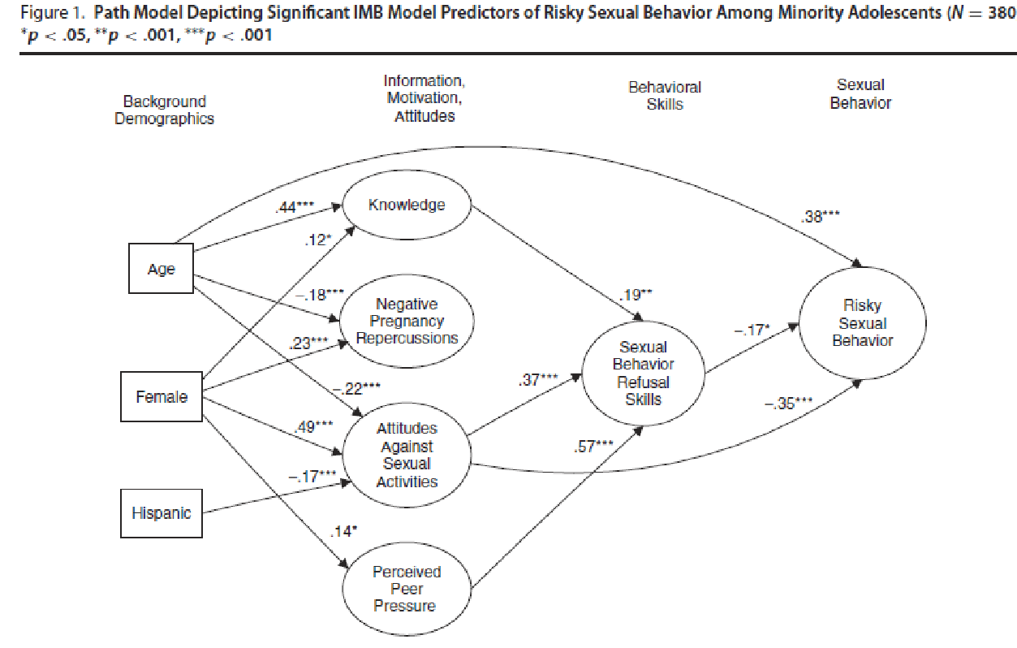

1. *Which two concepts have the strongest direct influence on risky sexual behavior?  Report the path coefficient number for each.*

The perception with strongest direct effect on risky sexual behaviors is

* Age (path determinant of 38***)
* Sexual behavior refusals (path determinant of -17*)
* Attitudes against sexual activities (path determinant t -35***)

1. *Which three concepts have a significant relationship with Sexual Behavior Refusal Skills? Report the path coefficient number for each.*

* Knowledge (path coefficient.-19**) indicating an indirect proportionality
* Attitude against sexual activities (path coefficient .37***) indicating a direct a proportionality
* Peer pressure (path coefficient .57**) indicating a direct proportionality.

1. *Which concept has the strongest influence on Sexual Behavior Refusal Skills? Report the path coefficient number.*

The thought peer influence or pressure has a strong effect on sexual conduct bearing a path determinant of .57**.

**Path Analysis #4**

*Provide thoughts about what you have learned from this assignment on path analysis. Also describe why path analysis is important to nursing practice and how it might be used. Be sure to be reflective and write at least ten meaningful sentences.*

Path analysis assignments are in possession of numerous avenues of learning to a nursing student as it provides a quick understanding relationship between various concepts. The intensive analysis of different variables evident in the path analysis assigning would also give the student how to relate different factors that have an effect on a disease. This topic mainly aids in analysis of relationship between variables that are significant in the nursing fraternity. One thing that I have learned from this topic is direct as well as indirect relationships. In direct association, an increase in a variable would lead to an increase in the corresponding variable. Conversely, in inverse proportionality an increase in a variable would lead to a reduction of another variable. In addition application of the level of significant in determining whether a guess is true or not has been another significant lesson that I was able to learn from the topic.

**References**

Clayton, M. F. & Pett, M. A. (2011). Modeling relationships in clinical research using path analysis Part II: Evaluating the model. *Journal for Specialists in Pediatric Nursing*, *16*(1), 75-79.

Pett, M. A. & Clayton, M. F. (2010). Modeling relationships in clinical research using path analysis part I: An overview of the process. *Journal for Specialists in Pediatric Nursing, 15*(4), 329-332.